**Web Design Trend: Flat Design**

**Website URL: http://www.wokine.com/**

**Landing page ScreenShot**

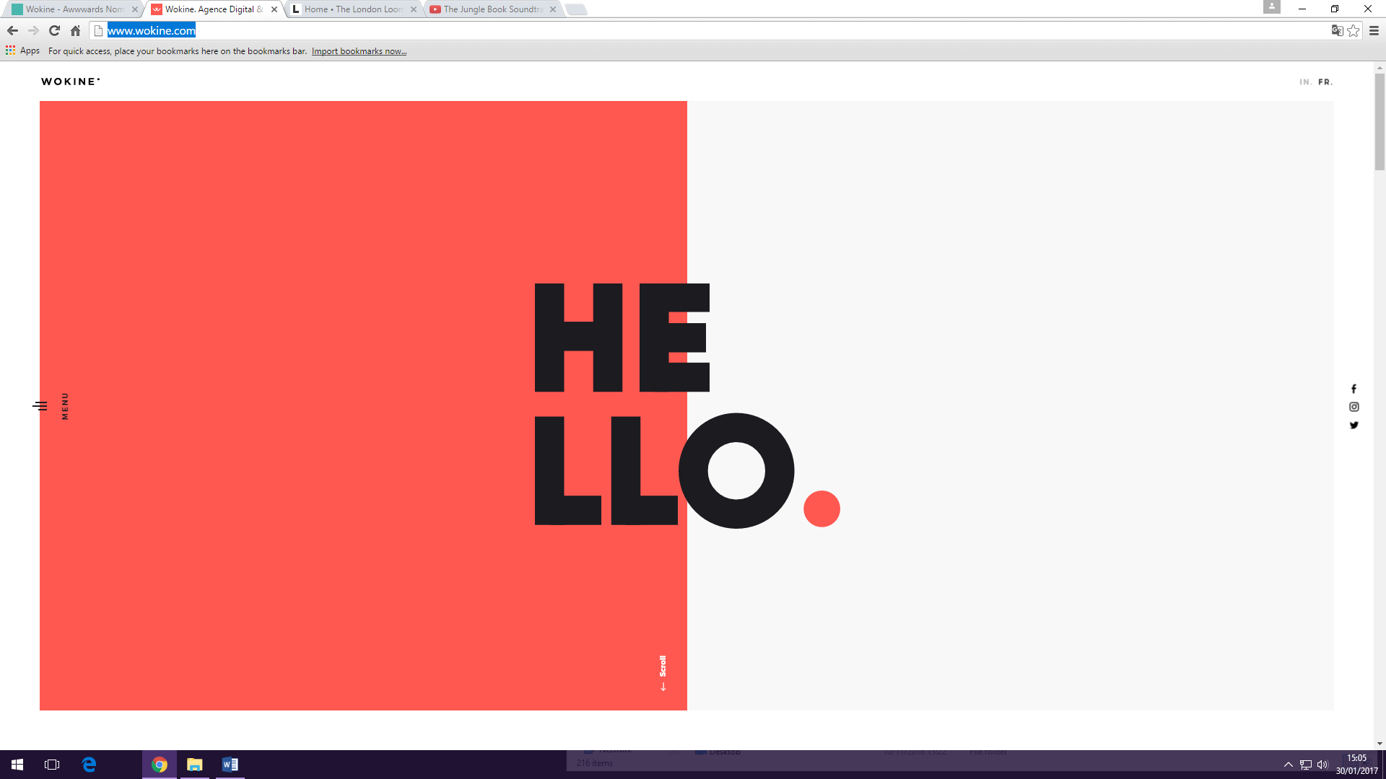

|  |  |
| --- | --- |
| **Element/Principle** | **Design Example** |
|  |  |
| **Line** | Not really any lines on the website |
| **Shape** | Mostly boxes, made of large squares |
| **Value** | No dark colours present, font is light in areas hard to read when the text is small |
| **Colour** | Use of contrasting colours, easy to the eye, too much variation, text is too similar so you have a hard time of reading the text |
| **Texture** | Smooth, not grainy or all in your face |
| **Size** | Text is too small, images are large, headings big and bold, captivates the users attention |
|  |  |
| **Contrast** | Yellow and white doesn’t work on website, purple and the white go well together, good contrast between the fonts but they do not keep it between using flat design by using many types of font |
| **Repetition** | The layout is consistent with a limited colour palette |
| **Alignment** | Layouts not messy, left aligned all headings are left aligned |
| **Proximity** | Numbers on the projects next to each other, but deemed difficult to read |
|  |  |
| **Space** | Plenty of breathing space, easy to read, good use of white space, equal amount of space |
| **Balance** | Nice website, navigation animation is all over the place and difficult, content is cluttered and confusing while scrolling through |